Phase Transformations in Diluted Al-Sc-based Alloys and Their Investigation

Martin Vlach
Department of Low Temperature Physics, Faculty of Mathematics and Physics, Charles University, Prague, Czech Republic

Abstract. Al-based alloys have a long tradition of use especially as a lightweight material for traffic systems. The limits of conventional casting have not yet been reached. One of the recent aims in the research of Al-based alloys is to realize the potential of non-traditional alloying elements such as transitions metals (TM) – e.g. Sc, Zr, Mn, Cr, etc. and their combinations. In this contribution we describe the excellent improvement of Al-Sc-based alloys properties (weldability, corrosion resistance, hardening and increase of recrystallization temperature) due to the presence of coherent, nanometer size Al₃Sc precipitates. We present also one of possible methods in an investigation of solid solution decomposition in Al-Sc-based alloys – electrical resistivity measurements as a response to isochronal and isothermal annealing.

Introduction

In the early years aluminum alloys were developed by a “try and error” method. It was detected before the World War I, that an age hardening is possible in an Al alloy (called Duralumin - alloy which contained additions of copper, magnesium and manganese) at room temperature. These useful properties of the material were utilized for instance in the famous airship called “Zeppelin” [1, 2]. Commercial Al-based alloys were the primary material of choice for structural components of aircraft since about 1930 [1]. Now, more than seventy years after, polymer matrix composites (PMC) are being used in modern commercial aircraft, e.g. for the horizontal stabilizer of the Airbus A340 and the Boeing 777, but conventional aluminum alloys still continue to be the primary material of choice for airframes (e.g. Boeings 7X7 comprise from more than 70 wt. % Al) [1].
Al-Sc-based alloys exhibit a unique combination of high strength and plasticity, corrosion resistance and weldability [3 - 7]. Mechanical properties of these alloys depend on their microstructure and their phase composition, so its knowledge provides an opportunity to improve material properties by thermal treatment. Electrical resistometry is successfully used in the investigation of phase development as a cheap and fast method, which decreases a number of required specimens for a direct observation by transmission electron microscopy (TEM).

Phase transformation in diluted Al-Sc-based alloys

The content of solutes is limited in aluminum alloys containing transition metals. The TM content does not exceed one percent due to the very low solubility of transition metals in solid aluminum – see binary phase diagrams – Fig. 1 (or e.g. figures in [8]). This figure also shows that for Al-Mn, Al-Cr and Al-Sc systems a temperature of invariant transformations, both eutectic and peritectic ones, is close to that of aluminum melting (933,47 K). In the case of solidification of aluminum solid solution, lines of solidus and liquidus come up closer to each other, i.e. solid solution has a very narrow solidification range.
Four intermetallic compounds exist in the Al-Sc system: Al₃Sc, Al₂Sc, AlSc and AlSc₂. The Al₃Sc forms an eutectics with Al at ~ 655°C and ~ 0,38 at. % Sc (0,47 wt. %) [3 - 5, 8]. The crystal structures and parameters of intermediate compounds are given in Tab. 1. The Al₃Sc phase is also reported to have an orthorhombic structure with parameters: $a=\text{0,50299nm}$, $b=0,\text{98945}\text{nm}$, $c=0,\text{31263}\text{nm}$ [9], nevertheless, this result is solitary in the literature.

The first Al-Sc alloy was patented by Lowell A. Willey (1971). He reported a substantial improvement of mechanical properties in various aluminum alloys upon adding 1% Sc at the most. This result gave rise to purposive investigations of phase diagrams, structures and especially mechanisms of hardening in aluminum alloys containing scandium [3].
Compound | Temperature  [°C] | Type | Parameter a  [nm] | Parameter c  [nm]
Al₃Sc | < 1320 | cP4  AuCu₃ | 0,4105  0,4103  0,4101 | -
Al₂Sc | < 1420 | cF24  Cu₂Mg | 0,759  0,758 | -
AlSc | < 1300 | cP2  CsCl | 0,3450 | -
AlSc₂ | < 1195 | hP6  InNi₂ | 0,4888  0,4885 | 0,6173  0,6166
Tab. 1: Crystal structures of Al-Sc compounds [3, 7 - 10].
Scandium is the most effective element having an antirecrystallization impact in aluminum alloys (Fig. 2). It increases recrystallization temperature of the material and thus products in the non-recrystallized state show improved strength properties [3].
Fig. 1: Equilibrium phase diagrams (Al-rich corner) for Al-Mn, Al-Cr and
Al-Sc [5].
The high influence of Sc on recrystallization is attributed to the high density of the Al₃Sc-dispersoids [3 - 5, 7, 11]. Thanks the similarity between the crystal lattice of Al-matrix and of Al₃Sc phase, the Al₃Sc-particles precipitate with a very high density as stable particles fully coherent to the matrix [3, 5, 7]. This effect on recrystallization disappears with the lost of coherency and with a particle growing [5]. The development of Al₃Sc-phase during the decomposition of supersaturated solid solution of Sc in Al depends on aging temperature, aging time and scandium concentration [4]. The precipitates are generally very stable with respect to coarsening, even after long aging times and their size is in the range of 1,4 – 10 nm [4, 12]. An attractive and veritable advantage is that the Al₃Sc phase is light (scandium is only 10% denser than aluminum) and it is unusually stable (up to 1320±7°C) [3, 4, 8], its parameters are given (see above) in Tab. 1. TheAl₃Sc precipitates remain coherent to a diameter of 20–30 nm, since the lattice parameter mismatch is ~ 1 – 1,25% at room temperature [3, 4, 8]. After the loss of coherency, their shape is reported to be spherical [4]. Toropova et. al [3] reported coherent precipitates of 5 nm in radius and inter-particle spacing of 75 – 100 nm after annealing (in an Al-0,3 at.% Sc alloy) at 375°C for 1 h; 10,1 nm in radius for 50 h and 13,2 nm for 100 h, both at temperature 350°C.

Electrical resistometry

Electrical resistivity has its origin in the simplest case in the scattering of free electrons by phonons and defects in crystal lattice such as dislocations, grain boundaries, cavities, solutes, point defects etc. Electrical resistivity is increased by any increase in concentration of lattice defects in metals. The total electrical resistivity of a dilute alloy may be written as Matthiessen’s rule [14]:
$ρ(T)=ρ_{p}(T)+ρ_{S}$, (1)
where ρ_{p} is the resistivity of pure crystal of solvent and represents mainly the phonon-electron interaction. ρ_{S} is the temperature-independent term (called residual resistivity) due to lattice defects such as solutes. This term can be expressed as the sum of contributions ρ_{k} for various kinds of defects as
$ρ_{S}=\sum_{k}{ρ_{k}}$. (2)
It is possible to write for low concentrations c_{k} of the k-type defects:
$ρ_{S}=\sum_{k}{ρ_{k}=\sum_{k}{β_{k}c_{k}}}$, (3)
where β_{k} is a constant assumed to be independent of temperature and concentration.
From experimental results is known that the requirements for Matthiessen’s rule are not always met. A deviation is observed due to
- β_{k} depends on temperature T,
- β_{k} depends on concentration of k- type defects,
- β_{k} depends on configuration of k- type defects.
During measurements at constant temperature T_{M}, changes in resistivity are equal to the changes of temperature independent term in Matthiessen’s rule:
${Δρ}_{S}=Δρ$. (4)
For relative resistivity changes we can write:
$\frac{Δρ}{ρ\left(T_{M}\right)}=\frac{{Δρ}_{S}}{ρ_{p}\left(T_{M}\right)+ρ_{S}}$, T_{M} = konst. (5)
Equation (5) implies that relative resistivity changes increase with decreasing temperature of measurement T_{M} and that it is advantageous to measure at low temperature (e.g. in liquid nitrogen or helium). Generally, assumptions of Matthiessen’s rule are not always fulfilled and one experimentally observes deviations that enable to study changes in the precipitation development.

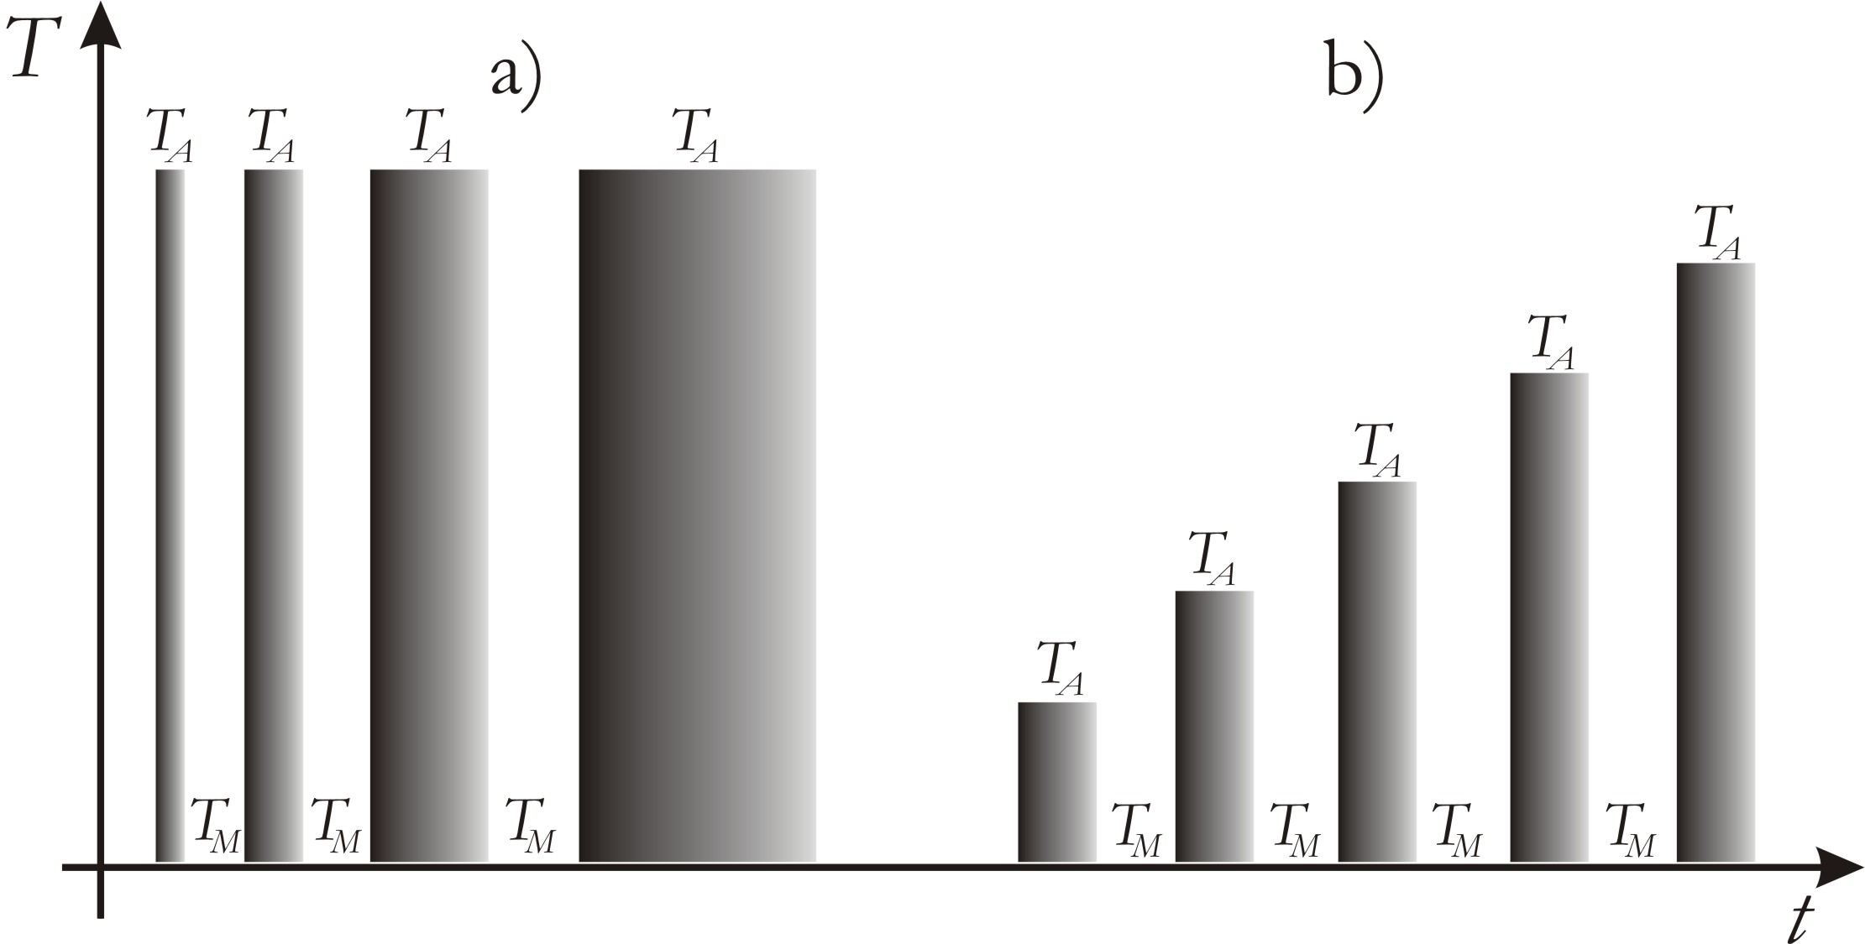
Experimental procedure

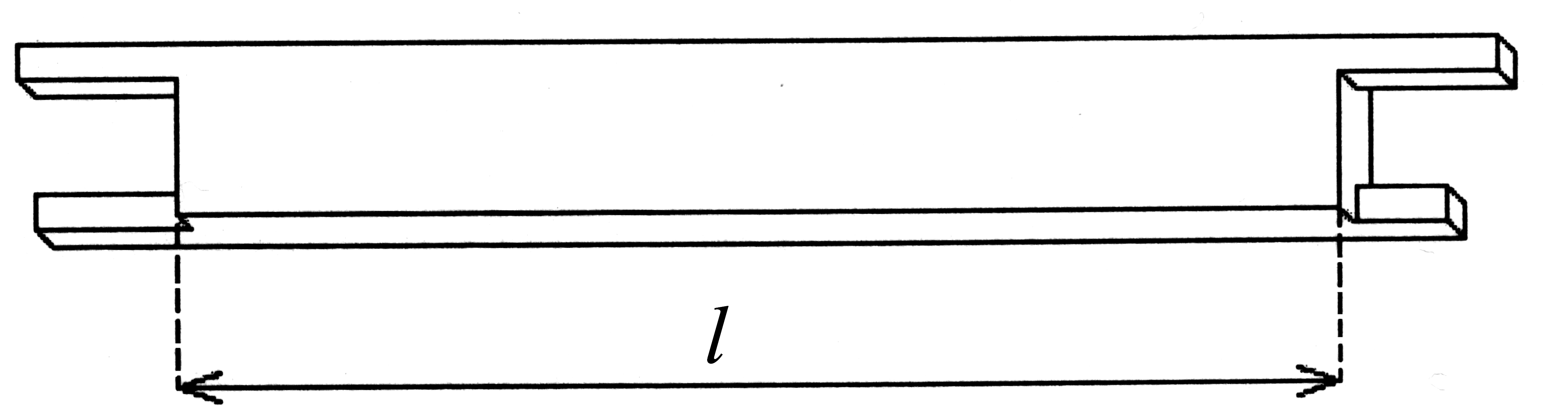
Relative resistivity changes are usually determined on isochronal and isothermal annealing in the range from 20°C up to ≈ 600°C. The isothermal (or isochronal) annealing carried out in steps of 30°C/30 min (Fig. 3) is followed by quenching. Heat treatment is performed in a mixed silicone oil bath up to 240°C (quenched into liquid nitrogen) and in a vertical furnace with an argon protective atmosphere or in air furnace (specimens wrapped in steel foil)at higher temperatures (quenched in water at room temperature). For measurements the H-shaped specimens are used (Fig. 4).
Fig. 3: Scheme of a) isothermal and b) isochronal annealing, T_{A} - annealing temperature,
T_{M} – temperature of measurement (77K).
Relative resistivity changes Δρ/ρ₀ are obtained within an accuracy of 10⁻⁴ [15, 16] (in our case it is achieved accuracy about 5.10⁻⁴) by means of the DC four-point method with a dummy specimen in series – see Fig. 5 – used for correction of temperature instability of the liquid nitrogen bath. It makes possible to suppress in the first approximation the effect of parasitic thermo-electromotive forces by current reversal and fluctuation of current on measured voltage. The electrical resistivity is measured at 77 K (liquid nitrogen) on each step and at two temperatures 77 K and 293K (in ethanol) for selected states of material.
Fig. 4: Schematic drawing H-shaped specimen, l presents the active length.

Conclusion

Crystal lattice defects influence all physical properties in metals. Thus one can get information about changes in microstructure of material using electrical resistometry. This method decreases the number of required specimens for direct observation by transmission electron microscopy.
Scandium is a very powerful addition in Al-based alloys. Most of positive effects of scandium are due to the decomposition of supersaturated solid solution. When added in small concentrations it refines the grain structure of cast metal and it assures a high precipitation hardening effect. The decomposition of supersaturated solid solution is characterized by the formation of fine equilibrium Al₃Sc precipitates. The Al₃Sc-dispersoids (Cu₃Au-type phase) coherent with the Al-matrix hinder efficiently recrystallization. Ranks of authors report that Sc reduces hot cracking during welding and gives the highest increase of strengthening of any alloying metal when added to aluminum. Zirconium forms the AlSc_{1-x}Zr_{x} phase together with scandium in aluminum, which increases the thermal stability of Al-Sc alloys. The additions of Sc to Al-Mg and Al-Mg-Si alloys are investigated now.

References

[1] Starke E. A., Staley J. T.: Application of modern aluminum alloys to aircraft, Pro 9. Aerospace Sci. Vol. 32, pp. 131-172, Pergamon, 1996
[2] Gunier A.: in Aluminium Alloys, Proceedings ICAA5, Part 1, Transtec Publications, Grenoble 1996.
[3] Toropova L. S., Eskin D. G., Kharakterova M. L., Dobatkina T. V.: Advanced Aluminum Alloys Containing Skandium – Structure and Properties, Gordon and Breach Science Publisher, The Netherlands 1998
[4] Marquis E. A., Seidman D. N.: Nanoscale structural evolution of Al₃Sc precipitates in Al(Sc) alloys, Acta mater. 49 (2001) 1909–1919
[5] Davydov V. G., Rostova T. D., Zakharov V.V., Filatov Yu. A., Yelagin V. I.: Scientific principles of making an alloying addition of scandium to aluminium alloys, Materials Science and Engineering A280 (2000) 30–36
[6] Smola B., Stulíková I., Očenášek V., Vlach M., Pelcová J.: Effect of Sc and Zr additions on the microstructure and age hardening of an AlMg3MnCr alloy Structure and age hardening of AlMgMnCrScZr, Materials Characterization 51 (2003) 11 – 20
[7] Norman A. F., Prangnell P. B., McEwen R. S.: The solidification behaviour of dilute aluminium-scandium alloys, PII: S1359-6454(98)00257-2, Acta mater. Vol. 46, No. 16, pp. 5715-5732, 1998
[8] Massalski Th. B. (Ed.): Binary Alloy Phase Diagrams, ASM, Metals Park, OH 1986
[9] Schuster J. C., Bauer J., J Less-Common Met., 40, no. 3, pp. 313-328 (1985)
[10] Cacciamani G., Riani P., Borzone G., Parodi N., Saccone A., Ferro R., Pisch A., Schmid-Fetzer R.: Thermodynamic measurements and assessment of the Al-Sc system, Intermetallics 7 (1999) 101-108
[11] Seidman D. N., Marquis E. A., Dunand D. C.: Precipitation strengthening at ambient and elevated temperatures of heat-treatable Al(Sc) alloys, Acta Materialia 50 (2002) 4021–4035
[12] Harada Y., Dunand D.C.: Thermal expansion of Al₃Sc and Al₃(Sc_{0,75}X_{0,25}), Scripta Materialia 48 (2003) 219–222
[13] Očenášek V., Slámová M.: Resistance to recrystallization due to Sc and Zr addition to Al–Mg alloys, Materials Characterization 47 (2001) 157– 162
[14] Kittel Ch.: Úvod do fyziky pevných látek, Academia, Praha 1985
[15] Sprušil B.: Czech. J. Phys. B15 (1965)
[16] Smola B., Stulíková I., Pelcová J., von Buch F., Mordike B. L.: Microstructure and Phase Changes Due to Heat Treatment of Squeeze Cast Mg-Sc-(Ce)-Mn Alloys, phys. Stat. Sol. (a) 191, No. 1, 305 – 316 (2002), WILEY-VCH, Berlin 2002
[17] Stulíková I., Smola B., Žaludová N., Vlach M., Pelcová J.: Development of electrical resistivity due to solution treatment of squeeze cast magnesium-rare earth alloys, Kovove Mater., 43, 2005, p. 272-279
[18] http://www.grada.cz (17th December 2005)

Transition metals – TM – metals with unpent electron shell, scandium has only one electron on the 3d shell and atomic radius of 0,165 nm.

