A Field Guide to Falling Snow
(from SnowCrystals.com)

Although no two snowflakes are exactly alike, snow crystal forms usually fall into several broad categories. These are useful for defining a common language to describe snow crystals. You can find a more descriptive guide in our new book – The Snowflake: Winter’s Secret Beauty.

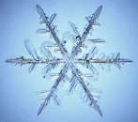
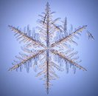
Stellar Dendrites
Dendrite means "tree-like", which describes the multi-branched appearance of these snow crystals. Stellar dendrites have six symmetrical main branches and a large number of randomly placed sidebranches. They can also be large, perhaps 5mm in diameter.
Although they have complex shapes, each stellar dendrite is a single crystal of ice. The molecular ordering of the water molecules is the same from one side of the crystal to the other.

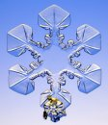
Sectored Plates
What identifies these crystals are the numerous ice ridges that seem to divide the plate-like arms into sectors -- hence the name. Like the stellar dendrites, sectored plates are flat, thin slivers of ice that grow into in a stunning diversity of complex shapes.
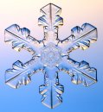

Hollow Columns
Plate-like snow crystals get the most attention, but columnar crystals are the main constituents of many snowfalls. The columns are hexagonal, like a wooden pencil, and they often form with conical hollow features in their ends.

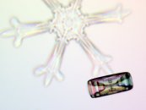


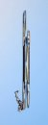
Needles
Columnar crystals can grow so long and thin that they look like ice needles. Sometimes the needles contain thin hollow regions, and sometimes the ends split into additional needle branches.

Spatial Dendrites
Not all snowflakes form as thin flat plates or slender columns. Spatial dendrites are made from many individual ice crystals jumbled together. Each branch is like one arm of a stellar crystal, but the different branches are oriented randomly.
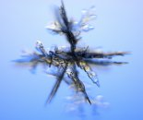



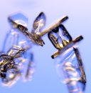
Capped Columns
These crystals started out growing as columns, but then suddenly switched to plate-like growth. This happens when a crystal is blown into a region with a different temperature.

Rimed Crystals
Snowflakes grow up in clouds, and clouds are made of small water droplets. Droplets that freeze onto a snow crystal are called rime, and these pictures show crystals that picked up a little rime and a lot of rime. Sometimes a snowflake turns into just a ball of rime, which is then called graupel, or soft hail.
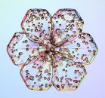
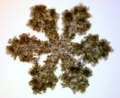


Irregulars
Snowflakes can have a hard life blowing about in a turbulent cloud, so that many arrive on the ground broken, ill-formed, and generally in bad shape. Warm snowfalls tend to bring the most irregular snowflakes, especially when the wind is blowing hard.

The pictures above were taken by Patricia Rasmussen using a special snowflake microscope built by Kenneth Libbrecht. For more information, see snowcrystals.com.

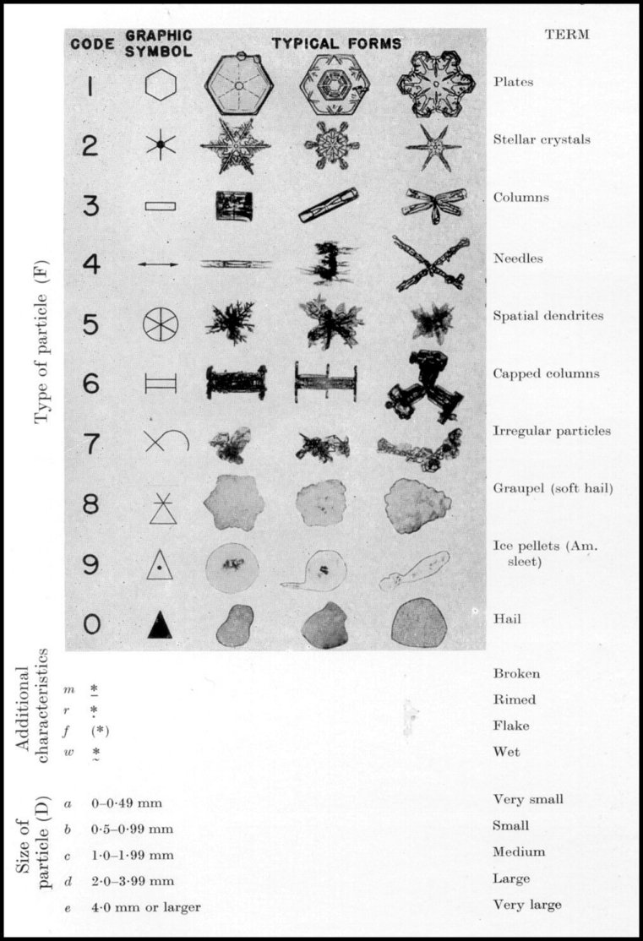

The above classification system provides a shorthand notation for describing falling snow. A large stellar crystal would be 2fe. A medium-sized rimed plate would be written 1rc.
The more detailed classification scheme below is by Magono and Lee.
